Code Review: I2306120
Reviewer: James Wood
Date: July 12th, 2023

Bugs

Preventative Action/Safety

Design/Architecture (Duplication, appropriate project, namespaces, maintainability)

Data Model (Naming, good design, needs index?)

Performance (Minimize DB hits, excessive loops, queries, scalable)

UI (Alignment, naming, standardization, tab order)

Error Handling (Behind events, appropriate parameter checking)

Cleanup (Dispose code, remove handlers, large data objects)
- Not your code, but we should be cleaning bad stuff up if we’re able to and it doesn’t change the behaviour. The cmd in this method is not cleaned up:
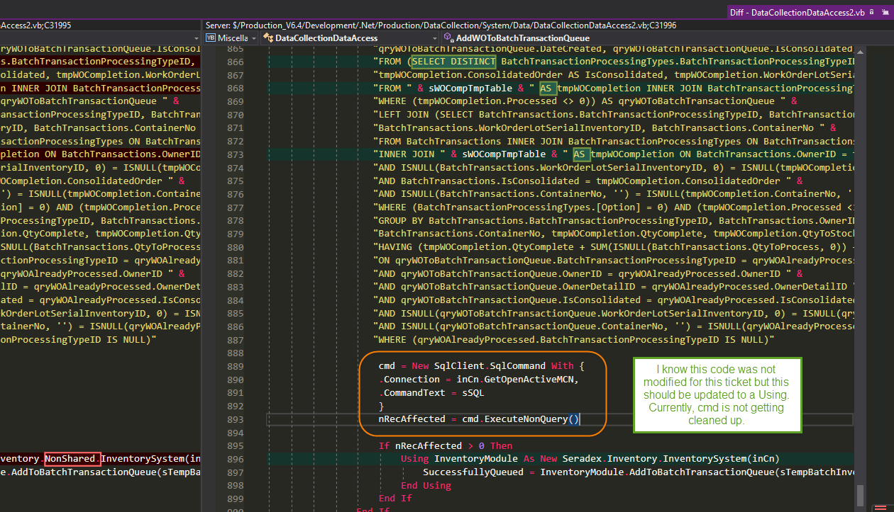
This should implement a Using, then we can also remove the Dim cmd statement.

Readability (Well-named variables, methods, clear algorithm, is it understandable)
- Nit: Depending on the code that I’m adding to, I may clean up some of the existing code to be more in-line with ours and MS standards. In the case of the PurgeBatchTransactionQueueTable method, I would make the following changes:
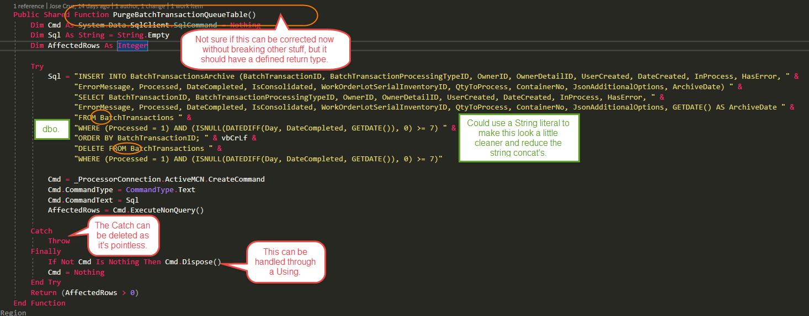
The modified method would look like this:
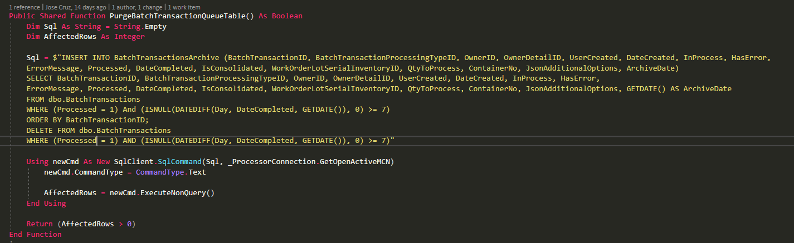
It’s cleaner and more streamlined. It does pass more space characters across the network, but from what I’ve read the packet size can accept queries up to 8000 characters in length, so a few extra spaces in this query shouldn’t be an issue.
Note, that none of these changes will affect the behaviour(except maybe the return type, but that would need some investigation), so there’s almost no risk to making them.
- Nit: Again, not your code. But having the Return statement outside of the method-wide Try-Catch is pointless. It should just be part of the main method behaviour code:
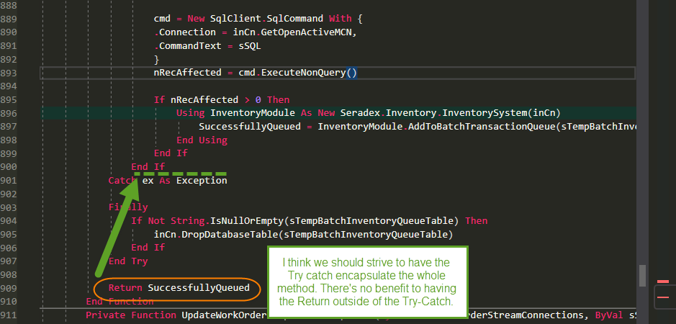

Comments (Useful, explains why rather than how)

Message Boxes (Grammar, spelling, captions, appropriate icons)

Ticket Management (Release Branch?, Testing Notes)

Extras

